
Lesson 9: On the Scoreboard
001 Game Creator (Windows only)
VIDEO GAME CREATION
This week: track a real score, and show it - along with your lives - on screen, all the time, not just at the end.
Open your own [YourName]Game project from Lesson 8 - don't start a new one.
Tip: no new assets this week - this is a logic and UI lesson.

Setup
- Open your [YourName]Game project from Lesson 8.
- Create a new Variable (Resources > Variables/Switches/Collections/Tables) named score, default value 0.
- Create a new Interface (this is a persistent on-screen layout, different from a one-off Message Box). Add a "Text / Graphic" Field to it for score, and another for lives.
- On each Field, under Use Values, set Retrieve Text/Value to the matching Variable (score or lives) - and IMPORTANT: tick "Update Real-time" on both Fields, so they refresh automatically as the Variables change.

Level 1 - Minimal (MVP)
Destroying an enemy adds 10 points to your score. Score and lives are both visible on screen, all the time, not just at the start or end of the game.
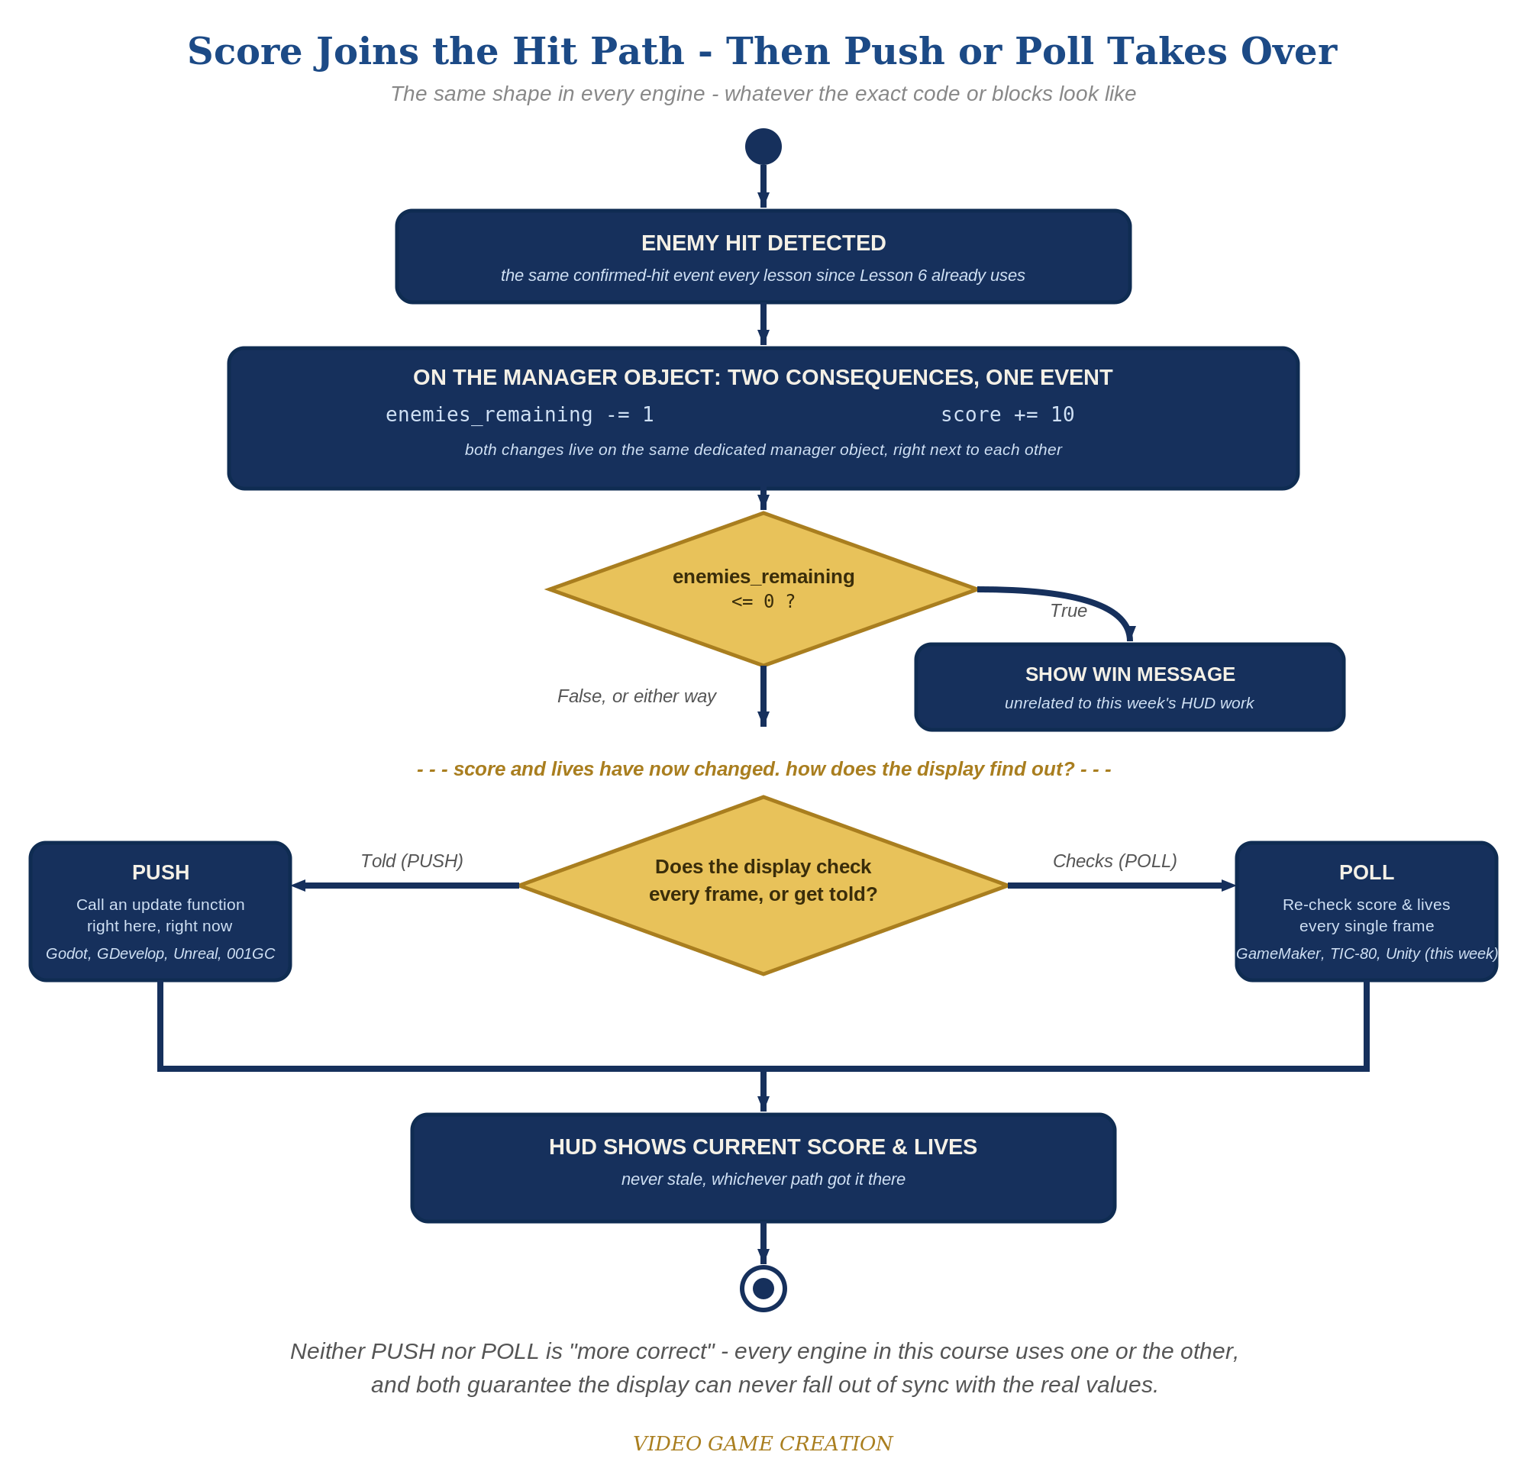
Score joins the hit path, then Push or Poll takes over - the same shape in every engine, whatever the exact code or blocks look like.
- On the enemy Actor Template's existing "Collided with actor" trigger, add a Variable event that increases score by 10, alongside the existing enemies_remaining decrement (code below).
- Save, then Play/Test and confirm your new Interface is showing (Interfaces may need to be set to display automatically at game start - check your Interface's settings if it doesn't appear).
- Shoot a few enemies and let one escape - both Fields should update immediately every time, with no need to reopen anything.
Highlighted lines are new this week; everything else is code you already have.
enemy Actor Trigger: Collided with actor ->
Variable – Modify Value(score, Add, 10)
Variable – Modify Value(enemies_remaining, Subtract, 1)
If(enemies_remaining <= 0)
Message Box("You Win!")
Actor – Destroy/Revive Actor(relate, Destroy)
Actor – Destroy/Revive Actor(this, Destroy)
Interface Field (Score): Use Values -> Retrieve Text/Value -> Variable: score, Update Real-time: ON
Interface Field (Lives): Use Values -> Retrieve Text/Value -> Variable: lives, Update Real-time: ON

Level 2 - Complete (Alpha/Beta)
The score and lives readouts never show a stale or wrong number - they always match reality, immediately.
- Shoot 3 enemies and confirm the Score Field reads exactly 30.
- Let an enemy escape and confirm the Score Field does NOT change - only the Lives Field should move.
- If a Field's number only changes after you close and reopen the Interface, its Update Real-time checkbox isn't actually ticked - go back and confirm it on both Fields.

Level 3 - Refined (Ready to Publish) - pick any that interest you
- Visual: try the \V[score] markup inside a styled Field label instead of a raw bound value, for more control over formatting.
- Visual: use a "Units" Field type (e.g. heart icons) for the lives display instead of a plain number.
- Structure: keep the score increment inside the same "Collided with actor" trigger as the enemies_remaining decrement - both are direct consequences of the exact same confirmed hit.

If Something's Wrong
- Score Field shows the right number, but only after reopening the Interface: Update Real-time isn't ticked on that Field - this is the single most common mistake this week.
- Interface doesn't appear at all when testing: check the Interface's own display settings - it may need to be explicitly set to show automatically at game/level start.
- Score changes when an enemy escapes: confirm the score increment is only in "Collided with actor," not accidentally added to "Left/Entered Camera" too.

Want More?
001gamecreator.com/wiki/field/, Student Resource List > 001 Game Creator

